1  x | 1  x |  | 2 | x
 | 4  x |  | 4  2  x  x |  | 3  x
3  5  x  x |  | 5  x | 6  x |  | 6  x
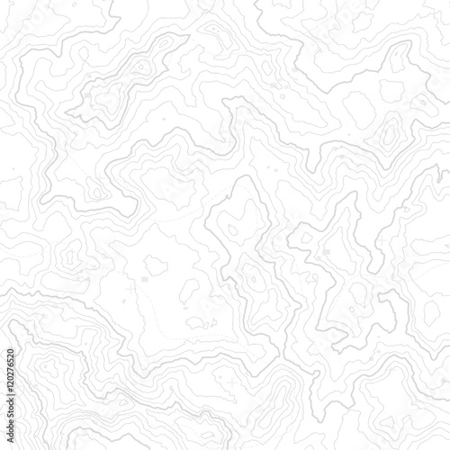
4348
100,000-Meter Square
FL
Grid Zone Designation
16S
34
33
32
31
29
4347000m N
28000m E
4350
4349
Scale 1: 25000

30

Determine 10-meter MGRS Coordinates for the marked positions.
1. 16S FL 2884 4964
2. 16S FL 3156 4913
3. 16S FL 3315 4906
4. 16S FL 3000 4860
5. 16S FL 2828 4744
6. 16S FL 3368 4791

Plot the following MGRS coordinates. Ensure you label you plots with the corresponding number.
1. 16SFL29734966
2. 16SFL32074967
3. 16SFL28174820
4. 16SFL31364870
5. 16SFL30764757
6. 16SFL31624730

